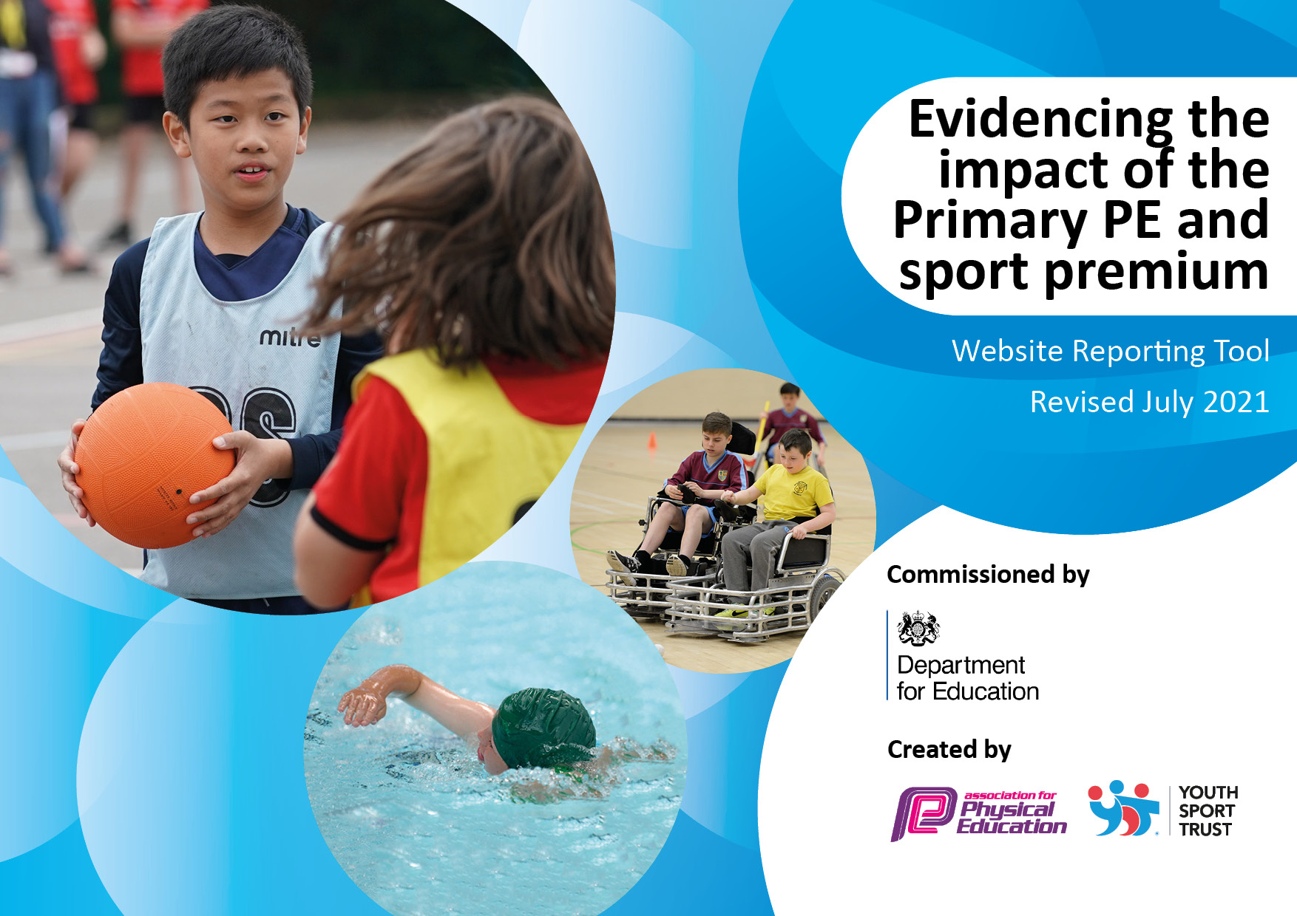
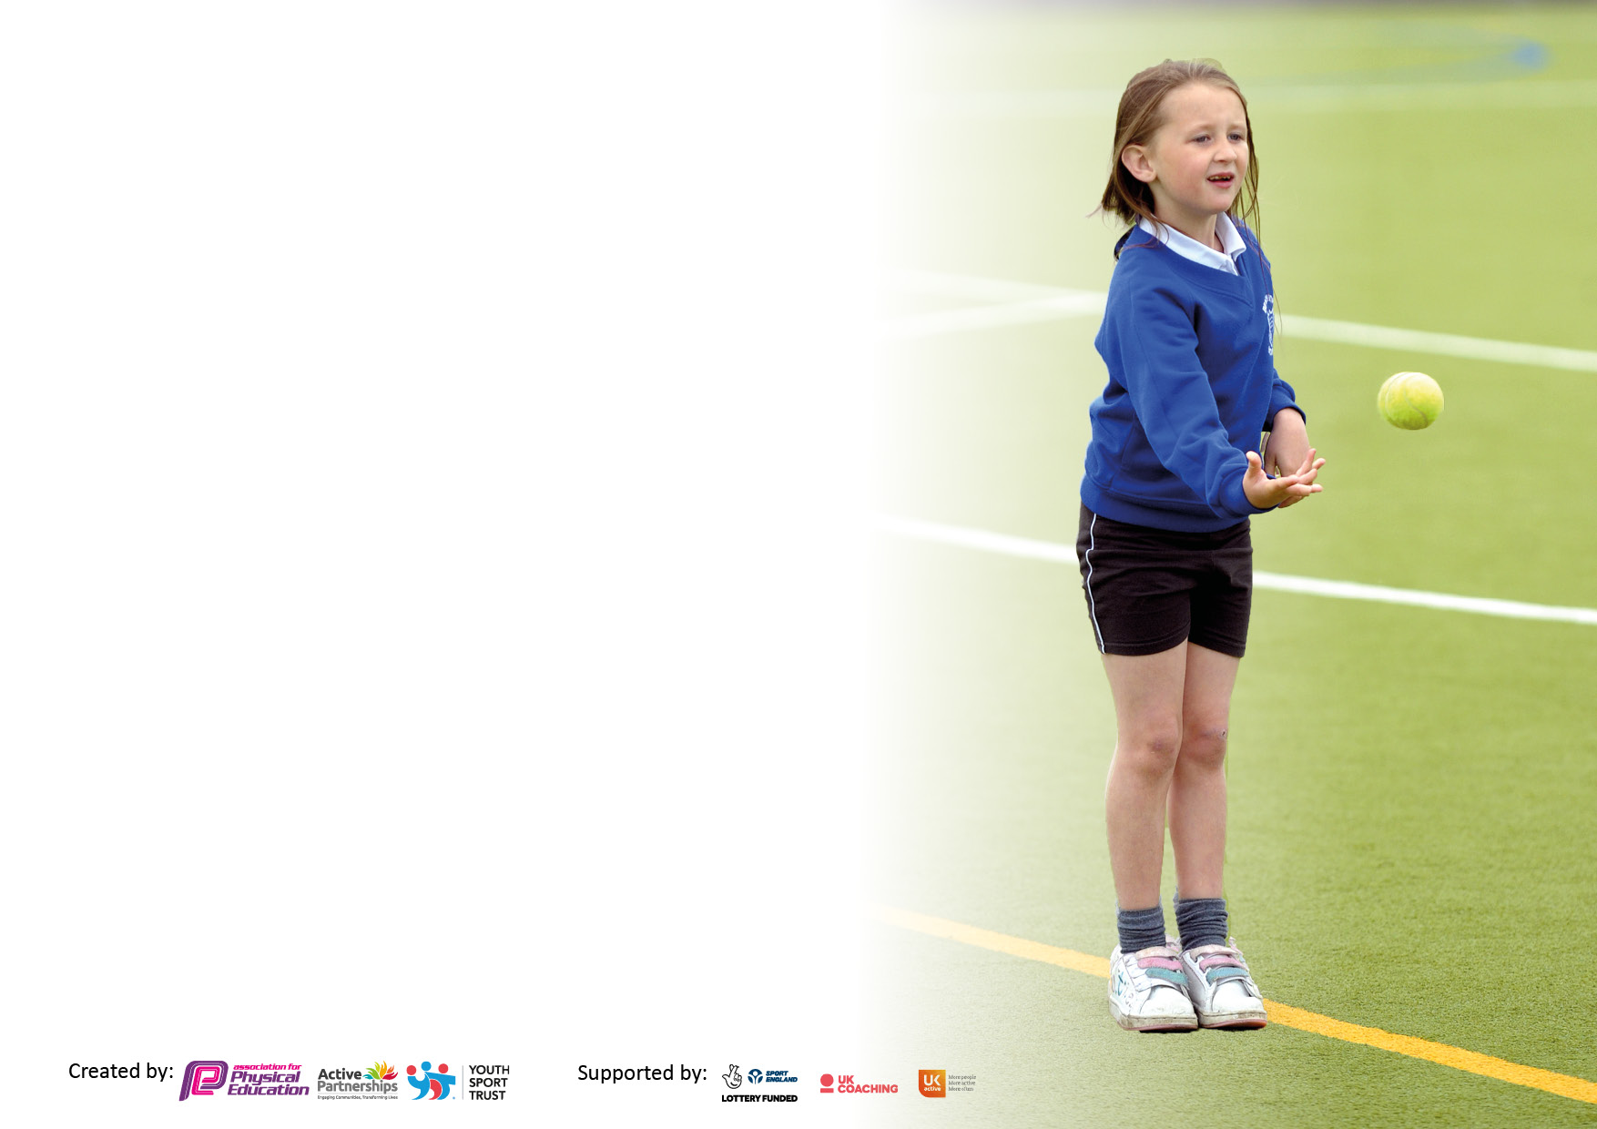

It is important that your grant is used effectively and based on school need. The Education Inspection Framework makes clear there will be a focus on ‘whether leaders and those responsible for governors all understand their respective roles and perform these in a way that enhances the effectiveness of the school’.

Under the Quality of Education Ofsted inspectors consider:
Intent - Curriculum design, coverage and appropriateness
Implementation - Curriculum delivery, Teaching (pedagogy) and Assessment
Impact - Attainment and progress

To assist schools with common transferable language this template has been developed to utilise the same three headings which should make your plans easily transferable between working documents.

Schools must use the funding to make additional and sustainable improvements to the quality of Physical Education, School Sport and Physical Activity (PESSPA) they offer. This means that you should use the Primary PE and sport premium to:

- Develop or add to the PESSPA activities that your school already offer
- Build capacity and capability within the school to ensure that improvements made now will benefit pupils joining the school in future years
- The Primary PE and sport premium should not be used to fund capital spend projects; the school’s budget should fund these.

Pleasevisitgov.ukfortherevisedDfEguidanceincludingthe5keyindicatorsacrosswhichschoolsshoulddemonstrate animprovement.Thisdocumentwillhelpyoutoreviewyourprovisionandtoreportyourspend.DfEencouragesschools to use this template as an effective way of meeting the reporting requirements of the Primary PE and sport premium.

We recommend you start by reflecting on the impact of current provision and reviewing the previous spend.

Schools are required to publish details of how they spend this funding, including any under-spend from 2022/2023, as well as on the impact it has on pupils’ PE and sport participation and attainment. All funding must be spent by 31st July 2024.

We recommend regularly updating the table and publishing it on your website throughout the year. This evidences your ongoing self-evaluation of how you are using the funding to secure maximum, sustainable impact. Final copy must be posted on your website by the end of the academic year and no later than the 31st July 2024. To see an example of how to complete the table please click HERE.

Details with regard to funding
Please complete the table below.

Total amount carried over from 2021/22 | £0
Total amount allocated for 2022/23 | £19,844.00
How much (if any) do you intend to carry over from this total fund into 2023/24? | £0
Total amount allocated for 2023/24 | £19,720.00
Total amount of funding for 2022/23. To be spent and reported on by 31st July 2024. | £19,720.00
Swimming Data
Please report on your Swimming Data below.

Meeting national curriculum requirements for swimming and water safety.

N.B. Complete this section to your best ability. For example you might have practised safe self-rescue techniques on dry land which you can then transfer to the pool when school swimming restarts.
Due to exceptional circumstances priority should be given to ensuring that pupils can perform safe self rescue even if they do not fully meet the first two requirements of the NC programme of study
What percentage of your current Year 6 cohort swim competently, confidently and proficiently over a distance of at least 25 metres?  N.B. Even though your pupils may swim in another year please report on their attainment on leaving primary school at the end of the summer term 2024.  Please see note above | 68%  All children to be offered discounted entry to Beswick swimming pool. Deals offered annually by GLL.
What percentage of your current Year 6 cohort use a range of strokes effectively [for example, front crawl, backstroke and breaststroke]?  Please see note above | 59%  All children offered discounted entry to Beswick swimming pool. Deal offered annually by GLL.
What percentage of your current Year 6 cohort perform safe self-rescue in different water-based situations? | 66%  All children offered discounted entry to Beswick swimming pool. Deal offered annually by GLL.
Schools can choose to use the Primary PE and sport premium to provide additional provision for swimming but this must be for activity over and above the national curriculum requirements. Have you used it in this way? | No

Action Plan and Budget Tracking
Capture your intended annual spend against the 5 key indicators. Clarify the success criteria and evidence of impact that you intend to measure to evaluate for pupils today and for the future.

Academic Year: 2023/24 | Total fund allocated: £19,720 | Date Updated: December 2023
Key indicator 1: The engagement of all pupils in regular physical activity – Chief Medical Officers guidelines recommend that primary school pupils undertake at least 30 minutes of physical activity a day in school |  |  |  | Percentage of total allocation: TBC
 |  |  |  | To be populated during the course of the academic year.
Intent | Implementation |  | Impact
Your school focus should be clear what you want the pupils to know and be able to do and about  what they need to learn and to  consolidate through practice: | Make sure your actions to achieve are linked to your intentions: | Funding allocated: | Evidence of impact: what do pupils now know and what can they now do? What has changed?: | Sustainability and suggested next steps:
The engagement of all pupils in regular physical activity – kick- starting healthy active lifestyles.  Children will be able to access high quality play and sports resources throughout the school week.  All children encouraged to increase their fitness through regular competitions and whole school events.  Ensure children are aware of the importance of a healthy lifestyle, including both diet and regular exercise and are able to verbalise this. | Daily Mile: sustain timetabling and monitor usage.  Ensure PE kits are always in school – letters to parents about PE kits being left in school. As new kit is being provided in spring by Primary Stars, older kit will be retired and used as spares for PE. To be communicated to all staff.  Monitor lunchtime sport crew and ensure pupils are accessing the activities – PE co-ordinator to monitor.  Continued CPD for Lunchtime Organisers to run and manage their games stations effectively and consistently. PE Co-ordinator to provide Lunchtime Organisers with updated Youth Sport Trust activity cards which will be the main focus activities for children at lunchtimes. PE Co-ordinator to provide with necessary sports equipment in bins for use by individual year groups to access all of the sports on the activity cards.  Staff members who are on duty at break and lunchtime will be provided with a PE activity booklet which will contain activities to be done with pupils.  Purchase new equipment for use at lunchtime and playtime.  Active sports membership to be renewed to ensure full access to all Team MCR inter-school activities.  AMPS M11+ schools’ sports cluster to attract more local school into inter-school activities.  AMPS intra-school sports leagues to be re-introduced.  Daily shake up activities – CPD for all new staff (and existing staff should opportunities be requested)  Subject leader to liaise with School Council to hear children’s voice about what clubs they would like to be implemented before and after school.  Promote community clubs for children to take part in outside of school.  Implementation of after school clubs.  Continue to work with SEMH provision to enable pupils to join year group PE lessons when appropriate.  Inclusion of all EHCP children within mainstream PE lessons.  Training for mainstream 121 TAs to support pupil engagement in PE lessons.  Implementation of Sports Leader Challenge posters. Design work to be extended to bookmarks, fridge magnets, Christmas mail postage stamps and Top Trumps style cards. | £750  £1745  £350 | I
Key indicator 2: The profile of PESSPA (Physical Education School Sport and Physical Activity) being raised across the school as a tool for whole school improvement |  |  |  | Percentage of total allocation: TBC
 |  |  |  | To be populated during the course of the academic year.
Intent | Implementation |  | Impact
Your school focus should be clear what you want the pupils to know and be able to do and about  what they need to learn and to  consolidate through practice: | Make sure your actions to achieve are linked to your intentions: | Funding allocated: | Evidence of impact: what do pupils now know and what can they now do? What has changed?: | Sustainability and suggested next steps:
Raising the awareness of physical education and sport to ensure all pupils understand the benefits of activity as part of a healthy lifestyle as well as the importance of learning and competing skilfully.  Pupils aware of sporting activities and achievements across the school.  Continue to encourage and support children in sports both in and outside school time. | Update sports noticeboard weekly. Signpost pupils to local sports clubs, local offers and events via the noticeboard and newsletter.  Monthly sport column in newsletter written by PE Co-ordinator – including weblinks to encourage home take up of new physical activities.  Implementation of a range of after school sports clubs.  Ensure newsletter provides information to engage pupils and families in physical activity. Include local offers for holidays and set challenges for pupils to achieve levels and experience different types of physical activity in the holidays and during school terms.  Prize for most active or most improved participant in Sport on Friday and lunchtime activities.  Continue new personal best scheme, plus the introduction of a challenge to improve book for all use. PE Coordinator to monitor use.  Actively share newsletters and posters from outside clubs – encouraging children to get involved.  Ensure class pages on school website are up to date and provide links to engage pupils and families at end of term. To include local offers for holidays and set challenges for pupils to achieve levels or types of physical activity in the holidays. | £50  £100  £100  £100

Key indicator 3: Increased confidence, knowledge and skills of all staff in teaching PE and sport |  |  |  | Percentage of total allocation: TBC
 |  |  |  | To be populated during the course of the academic year.
Intent | Implementation |  | Impact
Your school focus should be clear | Make sure your actions to | Funding | Evidence of impact: what do | Sustainability and suggested
what you want the pupils to know | achieve are linked to your | allocated: | pupils now know and what | next steps:
and be able to do and about | intentions: |  | can they now do? What has
what they need to learn and to |  |  | changed?:
consolidate through practice:
Improved quality of teaching and learning in PE, ensuring pupils are competent and confident. | Teachers to continue to receive individual coaching CPD through CITC offer.  PE Coordinator to continue to develop staff through their participation in Sport on Friday activities.  As the Sport on Friday offering increases, more staff to be recruited to deliver different activities.  Continued CPD for all staff re personal best scheme.  CITC to work with staff on formative assessment.  Extra-curricular time allocated to the teaching of PE. Teachers will be presented with an up to date activity booklet which gives them PE activity ideas for their extra-curricular time. Each year will be given their own sports tub full of sports equipment.  Further development of PE department to offer a better trained team of staff to actively manage inter and intra school competitive and non-competitive sporting activities. More staff will be recruited to the team this academic year which will enable the school to deliver more PE activities to more children.  Staff questionnaire to inform confidence in knowledge and skills required to teach PE further. Bespoke professional development to be planned to support needs. | £13,500
Key indicator 4: Broader experience of a range of sports and activities offered to all pupils |  |  |  | Percentage of total allocation: TBC
 |  |  |  | To be populated during the course of the academic year.
Intent | Implementation |  | Impact
Your school focus should be clear | Make sure your actions to | Funding | Evidence of impact: what do | Sustainability and suggested
what you want the pupils to know | achieve are linked to your | allocated: | pupils now know and what | next steps:
and be able to do and about | intentions: |  | can they now do? What has
what they need to learn and to |  |  | changed?
consolidate through practice:
Additional achievements:  To enable pupils to experience a range of sports and activities so that they can connect with something they enjoy and feel confident at and then continue to learn, be active and play which will develop increased confidence and self-esteem and a real love of sports and activities. | Pupil voice to be continued for choices of sports for competitions with local schools and within school, Sport on Fridays and lunchtime activities.  CITC activities to continue – planning checked and agreed to ensure variation in half termly activities to ensure that the teaching of skills covers a range of sports for EYFS right up to Y6.  Years 1 – 6 enrolled in Team MCR inter school competitions.  SEND children to access Panathlon virtual inter school activities. Targeted least active children to take part in inter school multiskills activities using the AMPS M11+ schools sports cluster.  School Games Day to be confirmed for July 2024 – Sport City track to be booked.  Signposting section on sports noticeboard to be updated regularly with new clubs and activities taking place locally. Leaflets distributed when received.  Sports Coordinator to develop Sport on Fridays / School Games Day offering (or appropriate day) for EYFS and SEMH pupils.  Reception to work with CITC re City Play. | £450  £1800

Key indicator 5: Increased participation in competitive sport |  |  |  | Percentage of total allocation: TBC
 |  |  |  | To be populated during the course of the academic year.
Intent | Implementation |  | Impact
Your school focus should be clear | Make sure your actions to | Funding | Evidence of impact: what do | Sustainability and suggested
what you want the pupils to know | achieve are linked to your | allocated: | pupils now know and what | next steps:
and be able to do and about | intentions: |  | can they now do? What has
what they need to learn and to |  |  | changed?:
consolidate through practice:
Focus on involvement of all pupils – not just elite players – through entering different types of competitions for different age groups and also organising local competitions and inter school competitions. The impact will be raised confidence in competitive situations and self-pride, as well as harnessing a love for competition.  Continue to develop the children’s involvement in local sport tournaments by increasing the number and variety of sports and varying the pupils who compete.  Arrange inter and intra competition of at least four per term.  Attract more schools to the AMPS M11+ schools sports cluster to enable children to compete (within walking distance). Targeting all cohorts of children to be organised by AMPS sport lead. | Inter and Intra school competitions including personal challenge will take place.  Year 1 – 6 taking part in Team MCR Inter and Intra competitions in September – July.  SEND children taking part in Inter and Intra Panathlon activities in January – July.  School Games: Review calendar and choose a varied range of competitions to encourage different pupils to compete.  Reluctant sports people: target festivals arranged to engage pupils who historically show no interest and arrange to host if nothing suitable is available.  PE co-ordinator to organise further different sporting competitions with local schools on our Astro pitch whilst growing the cluster of schools we engage with.  PE co-ordinator to keep sports board up to date to enable pupils to see results and celebrate success. | £100 | .

Signed off by
Head Teacher: | L.THOMAS
Date:
Subject Leader: | J.WALL
Date: | 04.12.23
Governor:
Date:

